**Lab 9**

**9.1 Write a program that input the marks of five students in an array and find the average.**

**SOURCE CODE**

#include<iostream>

using namespace std;

int main()

{

int array1[5], a=0,average=0;

cout<<"Enter the marks of 5 students"<<endl;

for(int i=0; i<=4; i++)

{

cin>>array1[i];

a = a + array1[i];

}

average = a/5;

cout<<"The average marks of the five students is: "<<average<<endl;

return 0;

}

**OUTPUT**

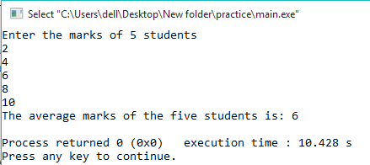

**9.2 Write a program that creates an array of 8 numbers and perform the following: a. Input a number from user and search in array if it is present or not. Also show the position. b. Find the highest number present in array.**

**SOURCE CODE**

#include<iostream>

using namespace std;

int main()

{

int array1[8]={8,16,6,4,12,2,14,10}, a=0,b=0;

cout<<"Enter the number to be checked"<<endl;

cin>>a;

for(int i=0; i<=7; i++)

{

if(a==array1[i])

{

cout<<a<<" is present in the array at position: "<<i<<endl;

break;

}

else if(i==7)

cout<<"Number is not present"<<endl;

if(array1[i]>=b)

{

b=array1[i];

}

}

cout<<"The highest number in array is: "<<b<<endl;

return 0;

}

**OUTPUT**

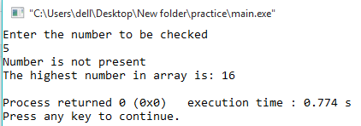

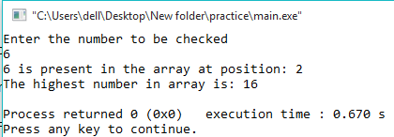

**9.3 Write a program to Convert Uppercase to Lowercase by using string functions.**

**SOURCE CODE**

#include <iostream>

#include <string.h>

using namespace std;

int main()

{

char str1[30];

int i;

cout<<"Enter the string in lowercase: ";

cin>>str1;

strupr(str1);

cout<<"The string in uppercase is: "<<str1<<endl;

return 0;

}

**OUTPUT**

